Concurrency, ADO.NET and the Disconnected Architecture

Road Map

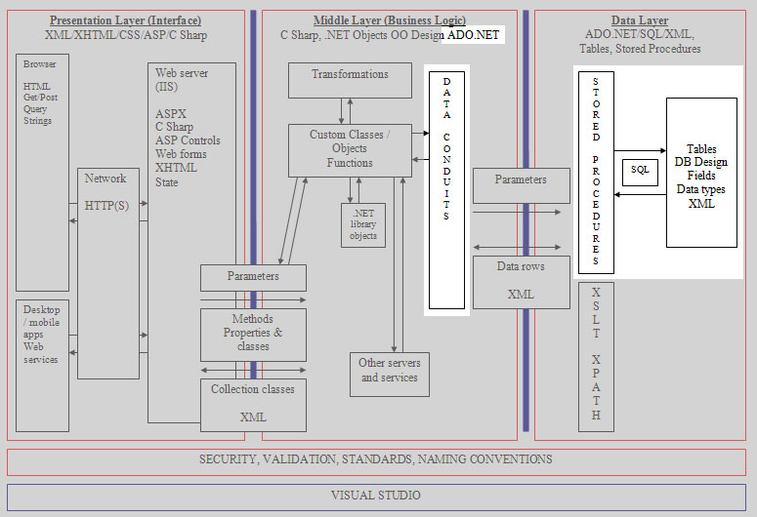

Introduction

In a single user system concurrency is not a problem. As soon as we introduce multi user system we have the issues of what to do when two users access the same data.

Lost Updates

User A reads a record
User B reads the same record
User A makes changes and writes to the database
User B makes changes and writes to the database
Updates entered by user A are lost

Second editor may have write access only when the first editor has done.

Uncommitted Dependency (Dirty Read)

User A opens a document and makes changes
User A saves the record while still working on it
User B opens the same record and prints out 100 copies
User A decides to not change the document and rolls back to the original state
User B has dirty data that should never be distributed

Second editor may only read the data once we know that the changes by the first editor are final.

Nonrepeatable Read

User A is talking to a customer interested in product X
The customer decides to go ahead with the purchase
User B now modifies the specification for product X
User A proceeds to the final stage of the transaction but sees that the specification has changed
There is no way of going back to the original read of the data

We need a mechanism for locking data during the span of a transaction.

Phantom Reads

User A is preparing a mail shot to customers
User A runs a query to generate the list of customers
User B edits a record for one customer, deletes a record for another and adds a new mail shot customer
User A is now working with data that has either changed or doesn’t exist (Phantom data)

We need a mechanism for locking batches of data to stop data being modified.

Disconnected Architecture

With an internet based application the connection between client and server is only open long enough to perform an action on the data.

Client
Server
I want some data
Get the data
Open connection
I have my data
Closed connection
Closed connection
Server
Client

Optimistic and Pessimistic Locking

- Pessimistic Locking

We assume a high chance of two records being modified simultaneously. When one user opens the record it is locked and another user may not access it until the first user is done.

- Optimistic Locking

We assume the chances of two people accessing the same record are unlikely. When we write back the data we check to see if the record was modified by another process / user.

Pessimistic Locking

The big problem with web applications is that the connection between client and server is only open long enough to do something then it is closed.

This disconnected model makes it impossible to apply pessimistic locking.

Optimistic locking is one approach but it still fails to solve many of the problems it simply tells us that there has been a problem.

Optimistic Locking

The main approach to optimistic locking is as follows...

- Read the data plus the current time stamp in the record
- Change the data
- Before we write back the changes see if the time stamp we recorded has changed in the original data
- If it is the same then write the data

There are three approaches we can take to optimistic locking in .NET

1. Use the data adapter
2. Use a time stamp
3. Check each field

Using Data Adapters for Optimistic Locking

So far we have used ADO.NET data tables to read data from the database like so...

clsDataConduit AllProducts = new clsDataConduit();
AllProducts.AddParameter("@ProductID", ProductID);
AllProducts.Execute("sproc_tblProduct_FilterByProductID");
AProduct = new clsProduct();
AProduct.Description = AllProducts.QueryResults.Rows[0]["Description"];
AProduct.ModelNumber = AllProducts.QueryResults.Rows[0]["ModelNumber"];
AProduct.Price = AllProducts.QueryResults.Rows[0]["Price"];
AProduct.ProductName = AllProducts.QueryResults.Rows[0]["ProductName"];
AProduct.ProductID = AllProducts.QueryResults.Rows[0]["ProductID"];

When we have written data back to the database we have placed the values into parameters and then passed those parameters to a suitable stored procedure.

For example...

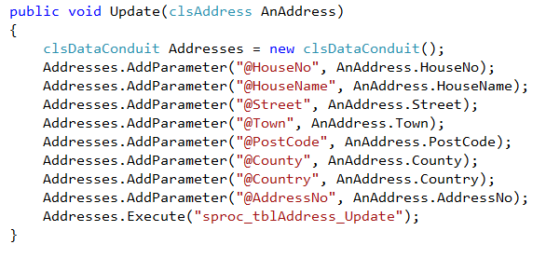

There is another approach to writing data to the database and that is by using the ADO.NET data adapter.

In creating the data conduits I had to take a number of design decisions in order to obtain the optimum design for a range of different issues.

In designing the data conduits to rely heavily on stored procedures (the best approach in my view) I have ended up neglecting other designs for the conduit and other aspects of ADO.NET.

Using the data adapter it is possible to allow it to handle updates, additions and deletes completely dispensing with stored procedures.

This being the case I have placed on the module web site a program that makes use of an additional data conduit called clsAlternateDataConduit. (DataAdapter Concurrency.zip)

This data conduit uses ADO.NET in a different way and creates a different set of methods and properties making it incompatible with the approaches taken so far.

Take a look at the following code that modifies a field in a data table...

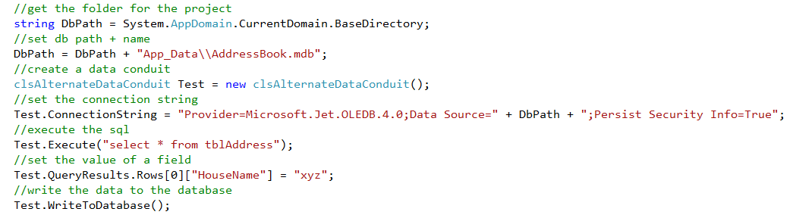

Take a look at the code for the Execute method in this new design...

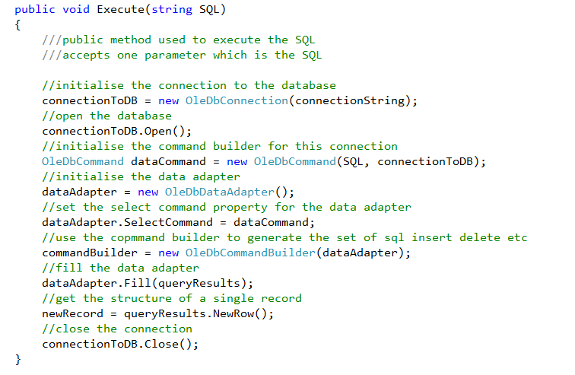

In this version of the code rather than initialising the command object with the name of a stored procedure we use some SQL...

We also don’t need to worry about using parameters in this design so no need for a loop to copy them into the command object.

There are a couple of other things to notice as we obtain the results of the query.

Firstly notice a new object called the command builder (OleDbCommandBuilder).

When we use a data adapter to manage data between our code and the database it needs to know what SQL it is supposed to be using.

It needs to know the SQL for ...

- SELECT
- INSERT
- UPDATE
- DELETE

Now it is possible to code these aspects ourselves however the command builder does it for us.

The command builder looks at the generic SELECT and creates the other SQL based on this. The command builder initialises the data adapter with these values.

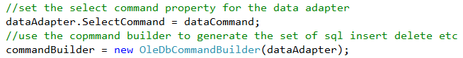

The other section of code to look at is the use of the new record object...

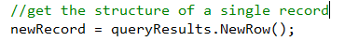

The property .New record equates to the place in an SQL server table where we type the data for a new record...

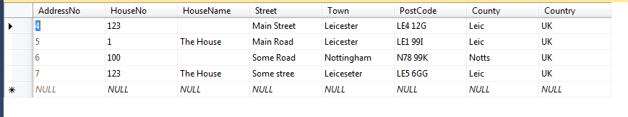

The newRecord object is an instance of the data row class which takes a copy of the record structure.

In this conduit the execute method sets up the data table with the results of the query and takes a copy of the record structure so that we may use both to manipulate the set of data.

The data table is exposed via the property query results...

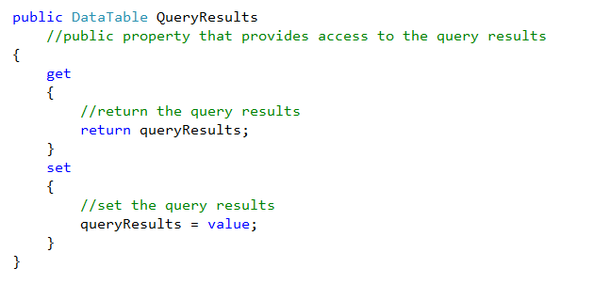

In this case we are allowing read and write access to the data table.

When we write new data to the data table via our conduit...

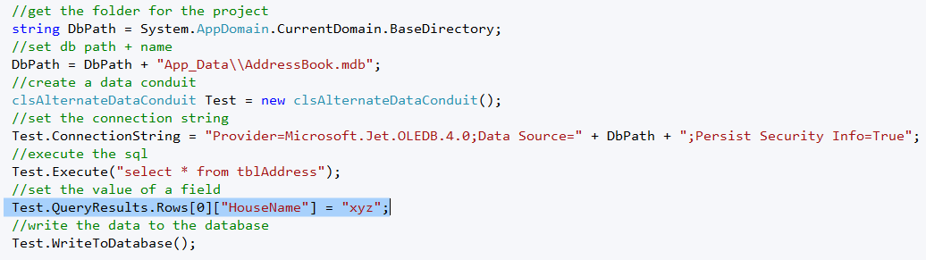

We then issue a command to the data adapter to write the data back to the database via the WriteToDatabase method which in turn uses the Update method on the data adapter...

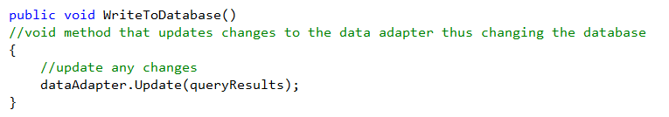

This then takes the data in the data table and writes it back to the database.

Where is this all going?

This new data conduit has been set up in order to demonstrate optimistic locking in ADO.NET.

The first step is to add a break point into the program on the line of code that writes to the database...

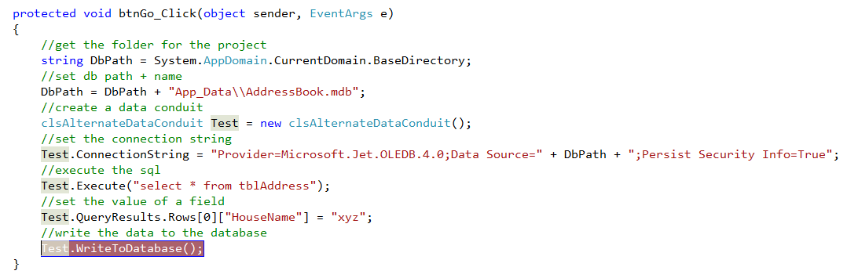

Now run the program and press Go...

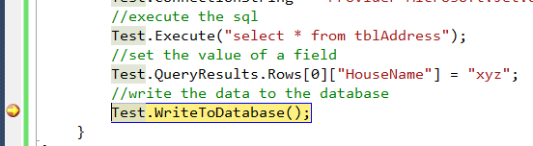

The code will stop at the break point waiting for further instructions.

The next step is to open the database in access and make a change to the record with index zero....

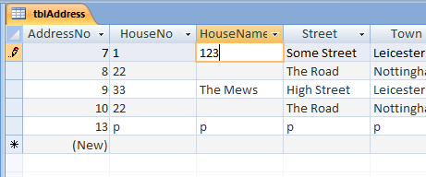

Change the house name to 123.

Save the changes.

Now go back to Visual Studio and the code should still be waiting for instructions.

What is about to happen is that the program is about to write “xyz” to the record where we have just changed the house name to “123”.

Press F5 and you should see an error...

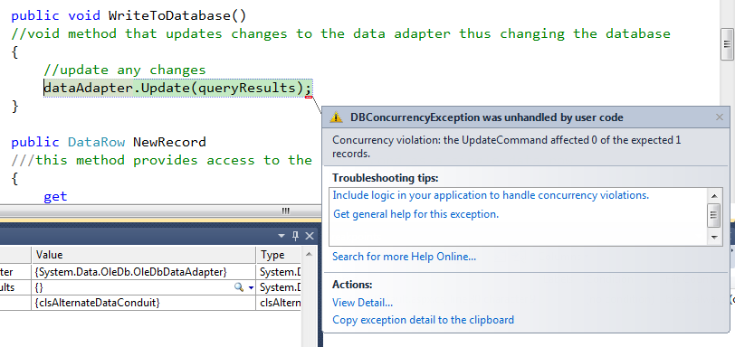

What just happened is that the data adapter has spotted that the data in the data table has been changed by another process and thrown an exception.

To handle the exception more gracefully we could modify the method like so...

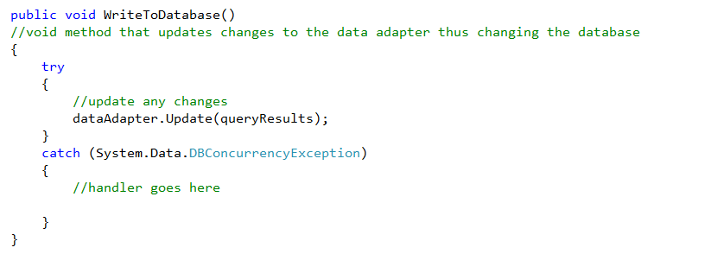

Using Time Stamps for Optimistic Locking

In the case of the data conduits we are using for the module we have relied heavily on stored procedures. This means that we cannot use the data adapters to test for concurrency issues and the functionality must be placed elsewhere, in this case the stored procedures.

In the lab work for this week you have the opportunity to implement this approach.

Modifying the Table

For this to work you will need to modify the table structure to incorporate a date/time stamp field like so...

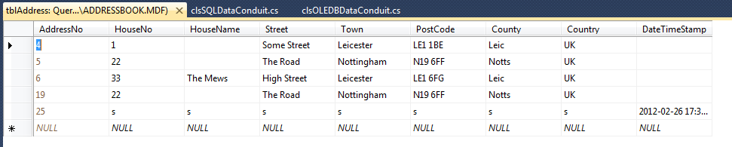

When we read data from the database we take a copy of the date time stamp...

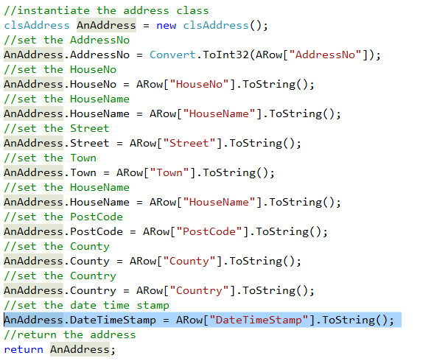

When we write data back to the database we pass the value obtained at the read to the stored procedure for updating the record. If the two values are the same then write the new data otherwise indicate an error...

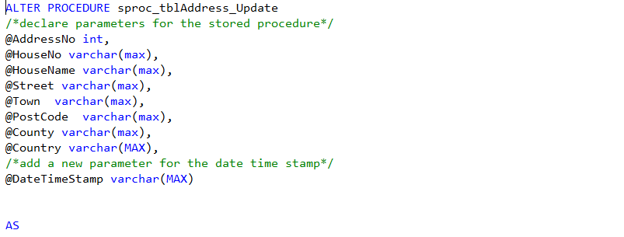
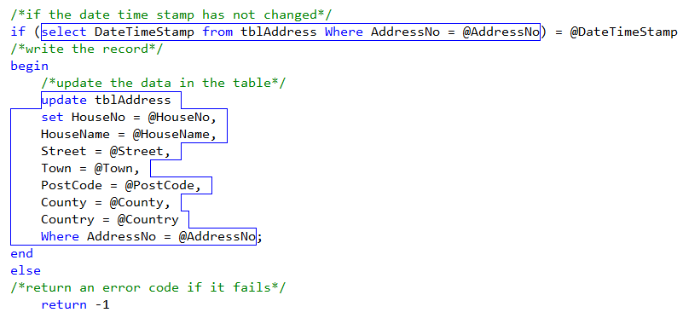

Checking Each Field

The third approach would be rather than using a time stamp but to check each field as we update...

update tblAddress
set HouseName = @HouseName
where HouseName = @OldHouseName
update tblAddress
set Street = @Street
where Street = @OldStreet

This approach requires a series of such updates in the stored procedure and it also doubles up the amount of data to be stored against a record.

